**CN Assignment 1**

Name: Erwin Wu

Student ID: 17M38147

**1. Visualize the network of Zachary's karate club.**

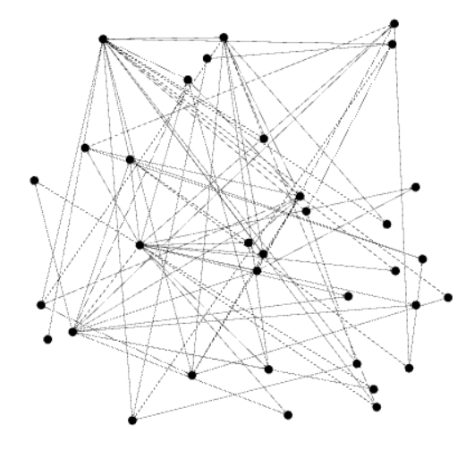

**2. Select two central vertices. Why do you think they are central?**

**Degree ranking:**

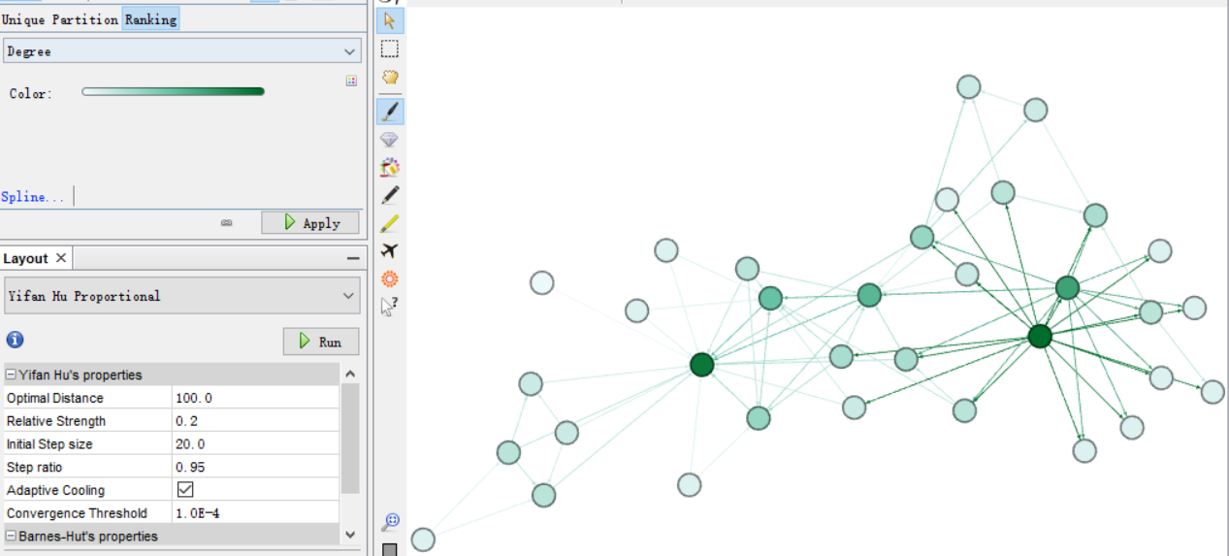

**Betweenness ranking:**

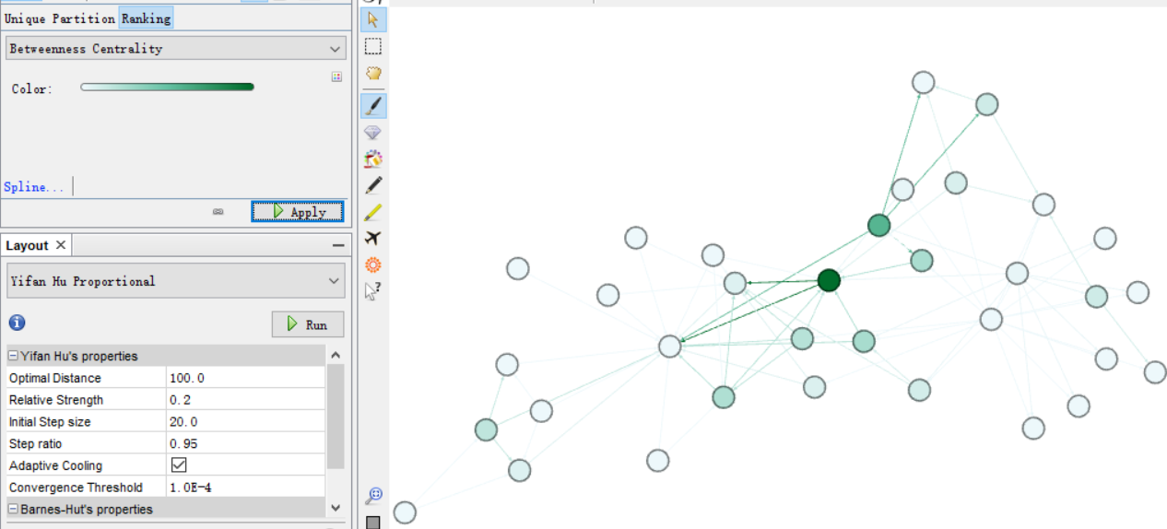

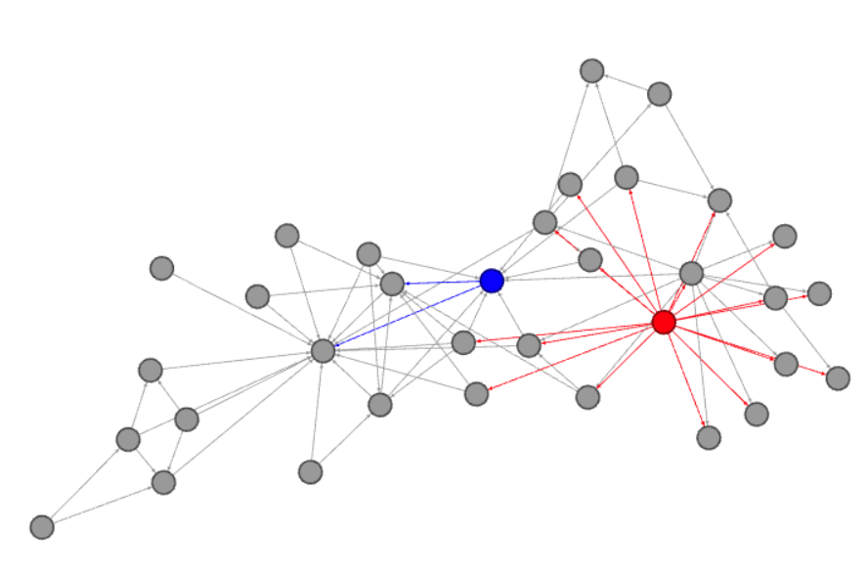

Red One: Degree centrality, because its degree is 17, which is among the highest in the graph.

Blue One: Betweenness centrality, its betweenness is among the highest (8.3333).

**3. Show the diameter, density, average path length, and clustering coefficient of the (undirected) network.**

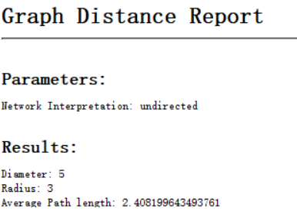 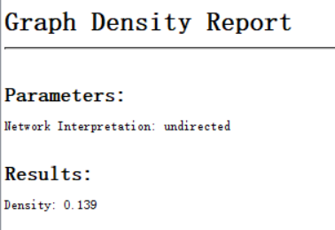

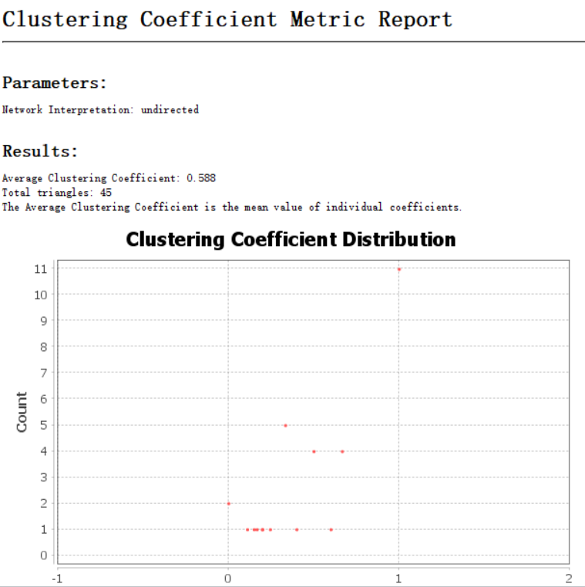

According to the data of Gephi for undirected network. The Network diameter is 5, density is 0.139, average path length is 2.408, average clustering coefficient is 0.588.

**4.** **Draw a degree distribution (a histogram of the degrees of vertices) of the network.**

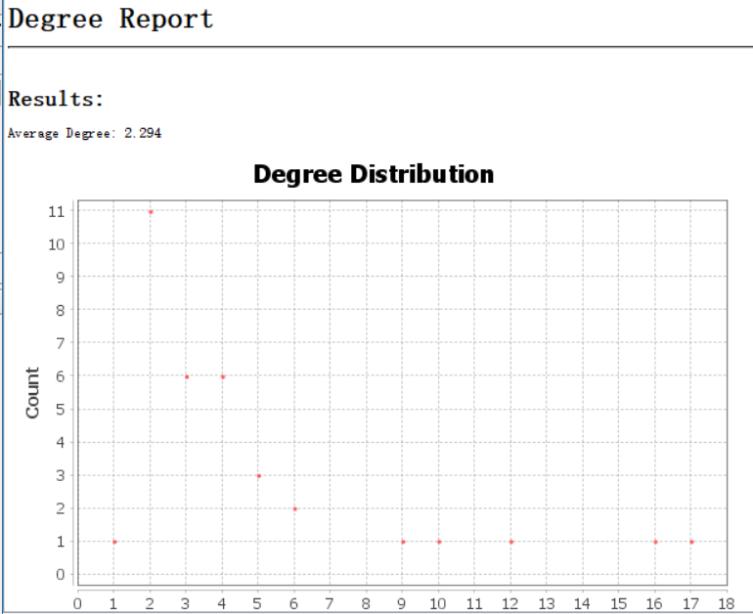

**5. Select two vertices whose PageRank values are the highest.**

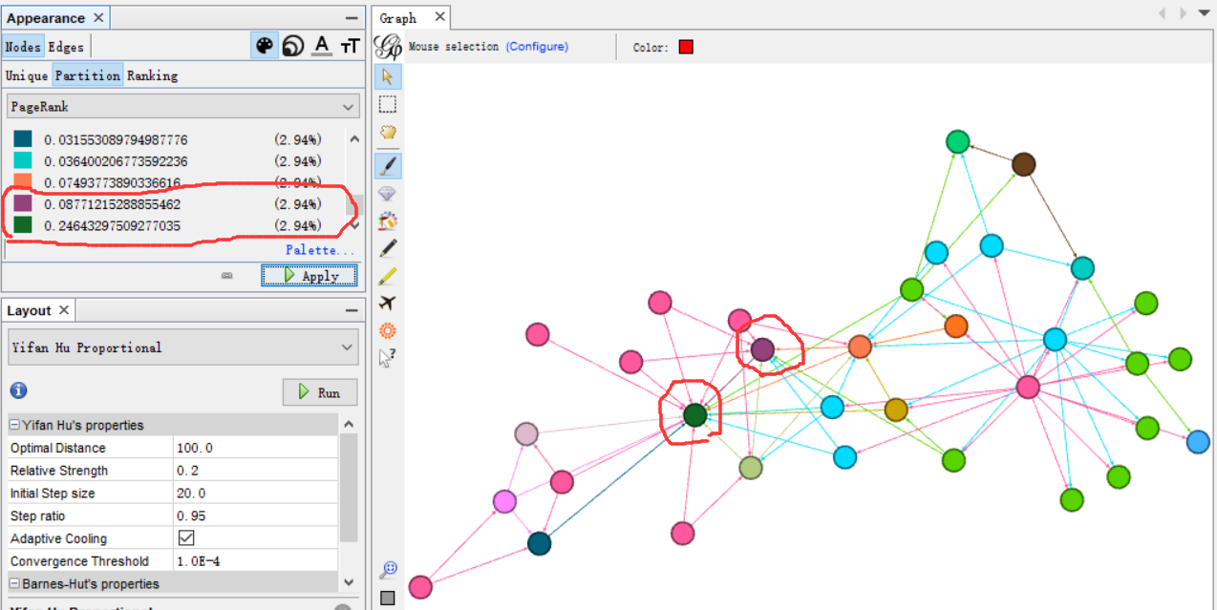

According to the PageRank, the dark green and the purple vertices (shown above) are the two with highest PageRank value (directed).

**6.** **Divide the network into small groups and answer its modularity.**

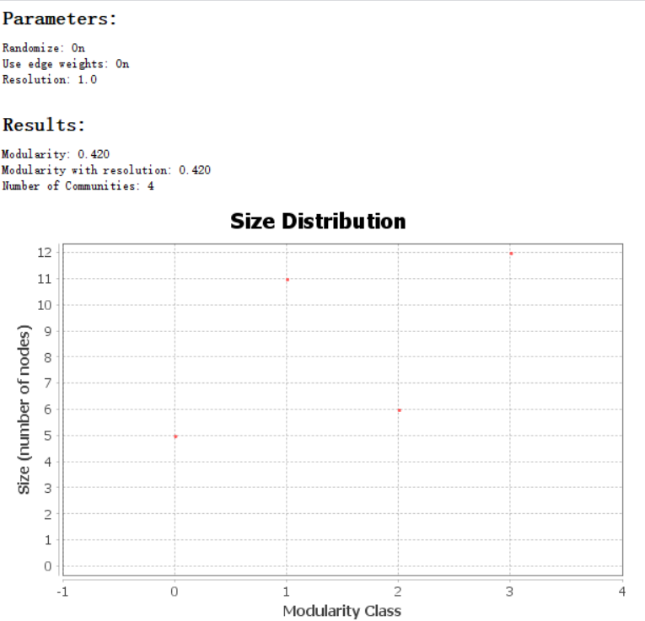

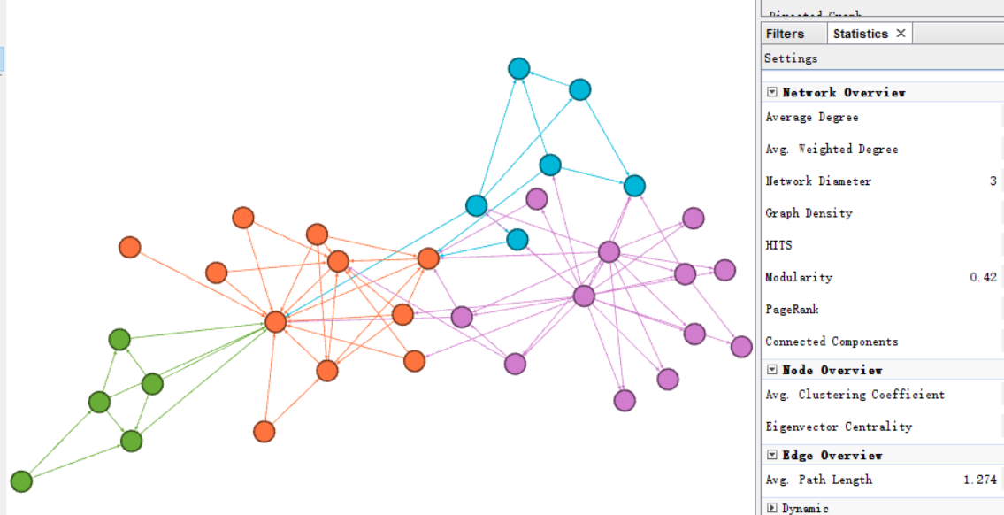

Hereby I divided the network into 4 groups of which the Modularity is 0.42